
See discussions, stats, and author profiles for this publication at: https://www.researchgate.net/publication/241682602
Building course cohesion: the use of online forums in distance Chinese language
learning
Article in Computer Assisted Language Learning · June 2012
DOI: 10.1080/09588221.2012.695739
CITATIONS
READS
16
120
2 authors:
Qian Kan
Robert Mccormick
The Open University (UK)
The Open University (UK)
11 PUBLICATIONS 74 CITATIONS
96 PUBLICATIONS 1,862 CITATIONS
SEE PROFILE
SEE PROFILE
Some of the authors of this publication are also working on these related projects:
Quasi-experimental study of English in Action, Bangladesh View project
Online Peer Mentoring View project
All content following this page was uploaded by Robert Mccormick on 07 September 2015.
The user has requested enhancement of the downloaded file.



Page 1 of 33
Computer Assisted Language Learning
1
2
3
4
5
Building course cohesion: the use of online forums in distance
Chinese language learning
6
7
8
9
10
11
12
13
14
15
16
17
18
19
20
21
22
23
24
25
26
27
28
29
30
31
32
33
34
35
36
37
38
39
40
41
42
43
44
45
46
47
48
49
50
51
52
53
54
55
56
57
58
59
60
This paper examines a sample of online discussion data from the course forum for
the large-scale beginners’ Chinese course offered by the UK Open University (OU).
This forum is open to all registered students, their participation is completely
voluntary, and they (rather than tutors) initiate communications. The aim of this
study is i) to seek to establish the nature, patterns of use and functions of forums
among distance language learners of beginners’ Chinese; ii) to provide a greater
understanding of the role and the significance of learner participation in online
forums and how forums contribute towards Chinese language learning; and iii) to
offer a fresh perspective to the understanding of distant Chinese language learning
experience, which is a relatively under-reported group of learners. Quantitative data
collected from questionnaires and qualitative data from interviews were analysed
together with the routine forum data. The analysis indicates that most students had a
very positive experience of the forum. The sense of belonging to a group with the
same shared goal of learning Chinese helped them meet the challenges of learning
Chinese. They perceived the online discussion forum as a virtual meeting place
where they could find support and help; and share their learning experiences,
resources, difficulties and frustrations as well as sense of achievement. Our analysis
also shows that the forum played a very important role in creating course cohesion,
supporting the learning of Chinese and making the learning process enjoyable and
fun.
Key words: beginners’ Chinese; distance language learning; online forum
1. Introduction
It is well-established in the field of second language acquisition at a distance that educators should
provide the following three interactions: learner-content; learner-instructor and learner-learner
(Moore & Kearsley, 1996; Moore & Kearsley, 2005; Ariza & Hancock, 2003). In distance
language learning, one of the challenges is the lack of face-to-face interaction between students
and tutors, students and students, and between students and ‘native’ speakers, which can result in
social isolation and anxiety (Hurd, 2005). This social isolation and anxiety can de-motivate many
students. The advance in internet and information and communication technologies (ICT) has
made it possible for language learners at a distance to interact and communicate with each other
synchronously and asynchronously, and this compensates for the deficiency in face-to-face
interaction and enables learners to ‘discuss and explore
information, ideas, problems, strategies, etc.’ (Kirkwood & Price, 2005). Online asynchronous
discussion forums are therefore used for all the Open University’s language courses as a means of
promoting interaction amongst students on the same course (other mechanisms are used for tutor-
student interaction). In this paper, we shall examine this type of text-based asynchronous
interaction among students on the beginners’ Chinese course.
1.1.
Online discussion forums
It is no longer necessary to argue for the benefits of online discussion forums in terms of
facilitating the learning, especially distance learning. The online forum studies over the last
URL: http://mc.manuscriptcentral.com/ncal



Computer Assisted Language Learning
Page 2 of 33
1
2
3
4
5
decade have indicated the following main benefits of this form of communication:
• facilitating collaborative learning (Thorpe et al, 2007; Curtis & Lawson’s, 2001);
• promoting learning and cohesion (Lamy & Goodfellow, 1999);
• encouraging learners’ reflections and experience sharing (Ng & Murphy, 2005);
• and students value online discussion and peer support (Hammond, 2000).
6
7
8
9
So, do any or all of the above benefits apply to adult distant learners on a beginners’ Chinese
course? Another question we hope to address is the patterns and nature of participation focusing
on the contributors as well as the content, for example, the study looked into issues such as who
are the active contributors, in what way the active contributors influence the forum participation,
etc. Although Hammond’s study (2000) investigated the nature and value of forums, the focus
was on the types of discussions rather than on the contributors to the discussions.
10
11
12
13
14
15
16
17
18
19
20
21
22
23
24
25
26
27
28
29
30
31
32
33
34
35
36
37
38
39
40
41
42
43
44
45
46
47
48
49
50
51
52
53
54
55
56
57
58
59
60
The above mentioned studies mainly looked at interactions between students and tutors or
between students and the content. Not many studies have investigated how learners interact with
other learners on the same course when they are not required to do course-related activities on the
forum, which is the context for our study. In other words, we are interested in the interaction
between students when the participation is completely voluntary and self-initiated in the adult
distance language learning context. Ng and Murphy (2005) studied a forum when participation
was voluntary but their main concern was to find out if content analysis techniques could be used
to analyse forum data. The students they studied were not language students. Very few studies on
online forums have been conducted in the context of distance language learning. Lamy and
Goodfellow’s study (1999) involved distant language learners, but their main concern was on how
tutors supported a group of French learners and how three small groups of learners on online
forums interacted with their tutors.
Furthermore, as distant Chinese language learners is ‘a relatively underreported group of
learners’ (Tasker, 2010), there is little research on the use of online forums in the context of adult
distance Chinese language learners. Although Zhu (2010) argues in a working paper that online
forum is one of the important motivational strategies in learning Chinese as it creates ‘the learner-
to-learner communication’, his argument is not supported by an empirical study. Also, he did not
look into the motivations of visiting forums and how forums might contribute towards Chinese
language learning, which is perceived as a difficult language to learn, as we shall now briefly
show. Jiang and Ramsay (2005) specifically investigate Chinese learning, in an exploratory study
of the role of tutor-student rapport in specific computer-assisted language learning (CALL), but as
we note later, their focus is not on student-student communication, and it is a small-scale study.
1.2.
Challenges in learning Chinese at a distance
The unique features of the Chinese language present many challenges to language teachers and
learners. Tones and characters are two of the biggest hurdles at the beginners’ level (Miracle,
1989; Liang & van Heuven, 2007; Jongman et al, 2006; Hu, 2010; Xing et al, 2004). There are
many similar sounding words in Chinese (Lü, C, 2010). Different tones are used to differentiate
the meanings between similar sounding words. Torgerson (2005, p.10) correctly points out:
‘Because tone is as important as the consonant or vowel sound in a word, an omission or
mispronunciation of tone is not only a mistake in pronunciation; it is sometimes an inadvertent
production of an entirely different word.’ As European languages do not use tones to distinguish
meanings, many European speakers find it very difficult to recognise the differences in tones (Hu,
2010). Characters are perceived as difficult because of their sheer number (Hu, 2010). The fact
that typologically there are no spaces between words boundaries and, most of all, the lack of
‘obvious sound-script correspondence’ makes learning especially difficult for beginners (Hu, 2010;
Xiao, 2010). Therefore, there have been a lot of studies on character-learning strategies (Ke, 1998;
URL: http://mc.manuscriptcentral.com/ncal

Page 3 of 33
Computer Assisted Language Learning
1
2
3
4
5
6
7
8
9
Yin, 2003; Lu, 2009). Many beginners feel that they are learning two systems at the same time –
pinyin (phonetic transcription of the characters, which are required for pronunciation and for
writing) and characters. Learning Chinese at a distance adds to these challenges:
• the lack of physical and visual presence of tutor and fellow students, which can be
isolating (Hurd, 2005);
• the lack of immediate feedback on both sides (to tutors and students) due to the physical
separation of tutors and students;
10
11
12
13
14
15
16
17
18
19
20
21
22
23
24
25
26
27
28
29
30
31
32
33
34
35
36
37
38
39
40
41
42
43
44
45
46
47
48
49
50
51
52
53
54
55
56
57
58
59
60
• the lack of speaking opportunities and interactions;
• the lack of time as most students either have a full-time or part-time job or other domestic
commitments;
• and the demands and frustrations of ICT (installing Chinese font, writing using word-
processing, converting between characters and pinyin, incompatibility between files, using
other online tools and software e.g. for dictionaries, etc.).
Considering the challenges in learning Chinese at a distance, it is very important for course
designers and the student-support staff to understand how students interact with each other, the
nature of their participation, why they visit the discussion forums, and most of all, if and how
forums can support learners to meet the challenges in learning Chinese at distance. In particular,
this study addresses the following research questions:
1. What are the patterns and the nature of students’ participation?
2. What are the main reasons students visit the forum?
3. In what ways does the forum contribute to the learning of the Chinese language?
In the next section, we shall describe the background of our study.
2. Background
Increasing demands in language learning through distance education led the Department of
Languages at the Open University (UK) to introduce Beginners’ Chinese to its curriculum in
November 2009 when 467 students were enrolled at the start of the course. The study reported
here was this first cohort of students who studied the course in 2009/2010.
2.1.
Course model and structure
Beginners’ Chinese was designed according to the blended learning model ‘that is facilitated by
the effective combination of different modes of delivery, models of teaching and styles of learning,
and founded on transparent communication amongst all parties involved with a course’ (Heinze &
Procter 2004). Based on this model, the course is delivered using a mixture of face-to-face
tutorials and synchronous online tutorials. There are about 20 students in each tutorial group and
this is called ‘Tutor group’. Students are provided with print and audio materials, interactive
online language activities and they are required, following a study calendar, to complete six
1
2
assignments and an end-of-course assessment. The course teaches Mandarin Chinese in its
standardized spoken modern form and in simplified characters. Students can study the course
independently or as part of a degree. The level of linguistic competence aimed at is comparable to
A2 as defined by the Council of Europe’s Common European Framework of Reference for
Languages (CEFR) (Council of Europe, 2001).
1
These are tutor-marked-assignments (TMAs).
The end-of-course assessment contains a Reading/Writing assessment, not marked by the student’s own tutor, and an
Oral Exam, which is marked by the tutor.
2
URL: http://mc.manuscriptcentral.com/ncal

Computer Assisted Language Learning
Page 4 of 33
1
2
3
2.2.
Students’ profile
Students can enrol from all parts of the UK and also from Continental Western Europe. Amongst
the 467 students who registered when the course first started, 45% were male and 55% female.
This is in line with that of undergraduates in full-time education studying Chinese in conventional
British universities (HESA, 2011). Usually there are more men learning Chinese than learning
most European languages, both at the OU and conventional British universities. The age profile
ranges from under 25 to over 65 years old, with more than 60% over the age of 40 years old (see
Table 1). Educational qualifications range from no qualification to holding postgraduate
qualifications. The age profile is in line with OU students overall (Coleman & Furnborough,
2010), whilst the percentage of students with undergraduate and postgraduate qualifications on the
Chinese course is higher.
4
5
6
7
8
9
10
11
12
13
14
15
16
17
18
19
20
21
22
23
24
25
26
27
28
29
30
31
32
33
34
35
36
37
38
39
40
41
42
43
44
45
46
47
48
49
50
51
52
53
54
55
56
57
58
59
60
<Table 1 about here>
2.3.
Online components
Most dedicated distance education courses now provide a virtual learning environment (VLE),
where both synchronous and asynchronous modes of communication are used to support teaching
and learning so as to ‘remedy the lack of interpersonal communications that has been “the
Achilles heel of distance education” (Guri-Rosenblit, quoted in Kirkwood & Price, 2006).
2.3.1. Course website
The course website, provided by a virtual learning environment (VLE ), plays a central role in the
3
Open University’s beginners’ Chinese course. The VLE provides the link between print,
electronic, audio and online learning materials as well as guides students through their weeks of
study, offers them a weekly study plan, digital resources, interactive activities, study tips, news,
online forums, etc. Students can also access assessment materials here too. In particular, to meet
the challenges of learning tones and characters, the VLE each week provides various tone
differentiation, speaking and listening activities, and character reading and typing activities .
Figure 1 shows part of the layout of the website from a student’s perspective.
<Figure 1 about here>
2.3.2. Forums
Research has shown that one of the main factors in being a successful distance language learner
relates to affective variables. According to Hurd (2005), ‘for the distance language learner, it is
perhaps affective variables – beliefs, motivations and anxiety – that are of greater relevance [than
other variables]’. Oxford (1990) holds a similar view: ‘the affective side of the learner is probably
one of the very biggest influences on language learning success or failure’. The challenges in
learning Chinese mean that students need considerable support, both academically and
emotionally. Previous research has shown that a substantial learner-support system is an essential
part in ensuring learner success and enhancing the learning experience (e.g. Simpson, 2002;
Moore & Kearsley 2005; Dreyer et al, 2005). In the OU, learner support can come from tutors,
academic units such as the course team, students’ services such as Computer helpdesks, and it can
also come from fellow students via course forums. This latter aspect is the focus of this study.
For the 2009/2010 academic year group, three forums were open to students who registered
with the Chinese course: general course forum, culture forum and café forum. The participation in
all three forums was voluntary and self-initiated. There were no specific language activities on any
4
of the three forums and they were not linked with the assessment. The course forum encouraged
3
This uses Moodle as the software base.
However, the culture forum did have a periodic topic from the print material introduced by a course member, but
there was no moderation or direction in addressing this.
4
URL: http://mc.manuscriptcentral.com/ncal

Page 5 of 33
Computer Assisted Language Learning
1
2
3
4
5
students to discuss all course-related issues. The culture forum encouraged students to share their
reflections and opinions in Chinese-speaking cultures encountered in the course materials. The
café forum was purely for arranging social activities. From the start of the course in November
2009 to its end in October 2010, there were 370 discussion topics on the course forum, 43 on the
culture forum and 29 on the café forum. As the course forum was the most active, our study
6
7
8
9
focuses only on this forum. However, there were ‘cross postings’, i.e. in the course forum, there
were discussions on Chinese culture and arrangements for social meetings.5
10
11
12
13
14
15
16
17
18
19
20
21
22
23
24
25
26
27
28
29
30
31
32
33
34
35
36
37
38
39
40
41
42
43
44
45
46
47
48
49
50
51
52
53
54
55
56
57
58
59
60
The course forum was open in October 2009, one month before the official starting date of the
course, and before most students had received any of the course materials. The discussion topics
were mostly generated by students; a small percentage by the course team or tutors (see Figure 2).
The most recent post appears at the top of the screen. However, if a student replies to a particular
post within a discussion topic, the reply appears directly after the post he or she replies to (see
Figure 3). It can make it rather difficult if someone simply wants to read the thread
chronologically as anybody can interrupt the flow of the thread and place his or her post in the
middle of a discussion topic. As any student can add a discussion topic (even if it already exists),
the list of topics can become very long.
<Figure 2 about here>
<Figure 3 about here>
In the following section, we shall describe how we collected and analysed the data from the
course forum and we will present the findings in Section 4.
3. Methodology
For this study, we used a variety of methods to collect and analyse data using both quantitative
and qualitative approaches to address the research questions given earlier. There were four basic
means:
• routine statistics collected from the web site about usage by students;
• questionnaires at the start of the course and at the end of the course, after the final
assessment had taken place;
• copying and analysing the contents of the forum;
• interviews with a range of forum users, including those who did not use it.
At this stage the general approach was exploratory and in most cases descriptive of the
students and their use of the online environment, particularly the forums. For each of the data
collection methods the samples, the questions asked (and/or data collected), and the analysis
carried out, are given in the next sub-section.
3.1. Methods
3.1.1. Routine statistics
The VLE enables the collection of routine statistics on user behaviour. Reports are available at
various stages in the course and specific ones can be carried out when required. In this article we
only report the usage figures and the record of the top contributors to the course forum covering a
six-month period at the beginning of the course. These data are based on the course population at
the instances reported (the statistics give frequency data). In addition there are routine statistics
available on students’ backgrounds, which are taken from their application form, and which is
available to course teams. In both cases the analysis produced descriptive statistics.
5
Because many students and tutors arranged their tutor group meetings in the course forum, a tutor group forum was
created for each tutor group in later presentations.
URL: http://mc.manuscriptcentral.com/ncal

Computer Assisted Language Learning
Page 6 of 33
1
2
3
4
5
6
3.1.2. Student pre-course questionnaire
This is a standard questionnaire administered to all OU language course students in their first year,
6
and is completed online, with students each being sent a link to the questionnaire. It covers
students’ language-learning background and also their motivations for studying the Chinese
course. Here we report on the reasons for studying Chinese and what students’ mother tongue.
The pre-course online questionnaire was sent to 245 students, of which 170 completed it (69%
return rate; though only 36% of all initially registered students). Again simple descriptive
statistics are used here, showing the frequencies. The age profile of the respondents is similar to
all initially registered students (Under 25: 5.7%; aged 25-29: 9.3%; 30-39: 20.1%; 40-49: 19.6%;
50-59: 22.2%; 60-64:19.9%; Over 65: 9.3%).
7
8
9
10
11
12
13
14
15
16
17
18
19
20
21
22
23
24
25
26
27
28
29
30
31
32
33
34
35
36
37
38
39
40
41
42
43
44
45
46
47
48
49
50
51
52
53
54
55
56
57
58
59
60
3.1.3. Post-course questionnaire
This is again an online survey completed after the course is complete, but before the final
assessment results are known to students (they do know how they performed on their continuous
assessment but not their overall performance). The survey focuses on students’ learning
experiences, including a specific section on their forum experience (see questions in Appendix 1).
The questionnaires were sent out to 247 students via an online link and 130 responded (54%
return rate or 29% of registered students). Again we only included the online returns. Of these
respondents, 60% were female, and 40% male; roughly the proportions of the initially registered
students.
3.2.
Forum content analysis
The VLE has a facility to ‘dump’ to a MS Word file all the forum messages at a particular instant
in the course. This was done in September 2010, enabling all the messages from October 2009
(the start of the course) to September 2010 to be captured. The first level of analysis categorised
the subject of each discussion topic (often referred to as a ‘thread’ in some implementations of
7
forums), based on its title. These topics were classified into six categories based on both our
research questions and on the most frequently occurring categories (using a grounded approach to
creating the category): ICT-related, language learning issues, resources, course material issues,
assessment related and cultural issues. Here we focus on language learning issues, resources,
8
assessment and course material issues. Although course material issues were mainly to do with
errors and queries, there were also discussions about learning tips. The second level of the content
analysis involved selecting discussions from these four topics and characterising the discussions
in terms of conceptual issues in the literature: promoting course cohesion, supportive, reflective;
sharing; and being positive. In addition it was evident that in the ICT-related discussions there
was an important element of technical support provided by students for each other, and we felt
this was a specific instance of sharing and support that was a more general theme than its
technical nature. (However, many of these discussions were nevertheless related to the use of
language-related tools.)
6
Paper versions were sent if students requested it, but only the online returns are used here.
Some tutors used this forum to set up meetings and make general announcements for their group. We did not include
7
those ‘discussion’ topics in our analysis.
8
Although we were interested in cultural issues, they consisted a small part of the discussions on the course forum
because of the fact that most cultural discussions took place on the culture forum. We therefore did not focus our
content analysis on these issues.
URL: http://mc.manuscriptcentral.com/ncal

Page 7 of 33
Computer Assisted Language Learning
1
2
3
3.3.
Interviews with a range of forum users/non-users
Inspection of the data on the use of forums, and particularly the number of postings to the forum,
enabled us to identify high, medium, low and non-users of the forum for more in-depth
interviewing. This was done using a semi-structured schedule (see Appendix 2), which formed the
basis for an open-ended conversational telephone interviews lasting between 30 and 60 minutes.
These were recorded and transcribed. A list of the range of users was compiled and emails sent
requesting participation and in the end 15 were interviewed (See Table 2 for their profile).
Interview transcriptions were analysed in terms of what they did on the forums, their motivations
for posting or not, and what benefit or not they obtained from them.
4
5
6
7
8
9
10
11
12
13
14
15
16
17
18
19
20
21
22
23
24
25
26
27
28
29
30
31
32
33
34
35
36
37
38
39
40
41
42
43
44
45
46
47
48
49
50
51
52
53
54
55
56
57
58
59
60
<Table 2 about here>
4. Findings
Data collected from different sources were connected during the process of analysis in order to
identify salient aspects of students’ online participation and to answer the three research questions
set out at the end of Section 1:
1. What are the patterns and the nature of students’ participation?
2. What are the main reasons students visit the forum?
3. In what ways does the forum contribute to the learning of the Chinese language?
The findings are structured according to the three research questions. Before we discuss the
findings, we would like to present two results from our pre-course online questionnaire: i) student
mother tongue; and ii) why study Chinese, both of which are relevant to our later analysis.
Regarding nationality and mother tongue, the majority of students were British with English as
mother tongue (over 82%), there were about 20% non-British students who either live in the UK
or in other European countries and, of those, 13.53% had other European languages as mother
tongue; in addition there were 1.76% Cantonese speakers, and 4.12% with ‘Other languages’.
Table 3 shows the top six reasons for studying Chinese. It is interesting that the two top reasons
are intrinsic, which is ahead of practical extrinsic reasons related to work and family life. This
result supports Coleman’s finding (2009) about distance adult learners who choose to study a
foreign language mainly for pleasure and intellectual challenge.
<Table 3 about here>
4.1. Patterns and nature of participation
4.1.1. Number of visits and frequency of visits
Although students’ participation on the forum is completely voluntary and self-initiated, our post-
course survey data shows that 90.8% of students visited the forum (including both contributing
and just reading) during the course of their study ‘regularly’ or ‘occasionally’ but we do not know
the percentage of ‘read only’ students (i.e. those who do not post a message). The same survey
also reveals that about 25% of students spent about 30–45 minutes, and about 44% spent less than
30 minutes per week, visiting the course forum (see Table 4).
<Table 4 about here>
The routine data comparing various activities on the course website each month, captured on
VLE, indicated that the course forum had the most visits (see Table 5). The Assessment area on
the VLE was visited by the most students because many of them went there to download the pdf
files of the assessment materials but, in terms of ‘number of visits’, the course forum is the
highest by a large margin. The course forum ranked the second in terms of number of students
visiting.
URL: http://mc.manuscriptcentral.com/ncal

Computer Assisted Language Learning
Page 8 of 33
1
2
3
<Table 5 about here>
4
5
6
7
Figure 4 shows the total number of unique forum user visits over the period on a week-by-
9
week basis. It is clear that the most active periods were related to those weeks when a particular
th
assignment was due (e.g. the first assignment was on 29 November 2009; the second assignment
8
9
th
was 10 January 2010). The forum was very active during these two weeks because there were
many technical issues to do with online submission and students went to the course forum for help.
Although it is not shown in Figure 4, many students visited the forum in the month before the
course started sharing their excitement about being the pioneer of the OU’s first Chinese course.
The huge enthusiasm and positive energy, in our opinion, helped to set up a generally positive
tone for the course forum.
10
11
12
13
14
15
16
17
18
19
20
21
22
23
24
25
26
27
28
29
30
31
32
33
34
35
36
37
38
39
40
41
42
43
44
45
46
47
48
49
50
51
52
53
54
55
56
57
58
59
60
<Figure 4 about here>
4.1.2. Nature of participation
Our study reveals two types of forum participation: i) active participation: reading as well as
10
posting messages; and ii) passive participation: reading only. Some students subscribed to the
11
course forum and every posting went to their personal email box. The email message contains a
link to the forum so those who wish to read or contribute could easily go into the forum. There
were many students who never posted but who read regularly. Data captured by the system
showed significant number of students and tutors who read some discussion topics (e.g. for a
discussion topic on the oral exam, 99 students and tutors had opened this discussion page). There
was also substantial evidence in the forum posting to support this, for example:
[…] the way people have participated in the forum is also astonishing, and I have
been grateful for the support, although I have not posted much.
12
[forum, Alice, our emphasis ].
One student who never posted but read most posts gave her reason in the interview:
I get through the most posts that were there. Whenever I had a problem, I would go
there. For e.g. how to install the font […]. There are so much there already. […] I
didn’t feel that I had anything extra to contribute.
[interview, Linda; our emphasis]
4.1.3. Top contributors (‘posters’)
Online discussion forums are populated with a range of people. The quality, the function, the
general tone and the usefulness of a particular forum is to a large extent determined by the
personalities, background and experiences of the student body. There was a critical mass of about
10 people who regularly initiated new discussion topics and replied to queries. From mid October
2009 to end of October 2010, there were over 4300 postings in total on the course forum alone.13
Figure 5 shows the number of messages posted by the top 20 contributors over the course of 11
months.
<Figure 5 about here>
9
This also includes the 17 tutors’ and 4 course team members’ visiting.
10
Note that ‘reading only’ refers to those students who never posted; the Moodle system could capture their visits but
could not identify who they were.
11
Sample data captured by the system shows at a particular time there were about 30-40 students who subscribed to
the course forum.
12
All names in this paper are pseudonyms.
13
This includes the 12 discussion topics with 509 postings created by some tutors for their tutor groups.
URL: http://mc.manuscriptcentral.com/ncal

Page 9 of 33
Computer Assisted Language Learning
1
2
3
4
5
Of these top contributors, 3 of them posted more than 250 messages and 14 of them posted more
than 50 messages; in all they posted almost half of the total of 4300 postings. Of the top 14
contributors who posted over 50 messages, 10 had formal higher education (HE) qualifications (6
of them had postgraduate qualifications); 2 had qualifications equivalent to HE, 1 with less than 2
6
7
14
A-levels but had done other OU courses previously. So they were all experienced learners.
8
9
Amongst the top 20 contributors, 10 were interviewed. Several of them had learnt some Chinese
before, or visited China, or were lecturers themselves and were experienced in providing support
and advice (but in different subject areas), and/or were extremely capable with ICT. Nearly half of
the top 20 subscribed to the forum at some stage during the course of their study, according to the
VLE data.
10
11
12
13
14
15
16
17
18
19
20
21
22
23
24
25
26
27
28
29
30
31
32
33
34
35
36
37
38
39
40
41
42
43
44
45
46
47
48
49
50
51
52
53
54
55
56
57
58
59
60
The results from the post-course survey and the interviews all indicate that most students spent
more time reading others’ messages than contributing, except the top two contributors who
probably spent equal amount of time reading and posting.
4.1.4. Types of discussion topics
Of the 370 discussion topics and over 4300 postings, some postings were simply to thank
someone for answering a question or sharing a useful file. As indicated earlier, discussion topics
were analysed and classified into the following six categories:
1. ICT–related
2. Language learning issues (tips, strategies, etc.)
3. Resources (books, websites, resources constructed by students)
4. Course material issues (errors, queries)
5. Assessment related
6. Cultural issues
But in every one of the categories there were messages asking for help, support, sympathy, or
sharing their joy and achievements saying things like ‘I now have 50 [Chinese] characters under
my belt!’. Also, in every category, there was useful feedback for the course team: e.g. errors in the
teaching material; useful tips on some technical issues the course team can use in the future; good
recommendation of grammar books and online resources; problems with tutors’ late return of
assignments. There was also a lot of diversion from the original discussion topic. For example,
one discussion topic started off with someone recommending a grammar book, and ended up in a
discussion on how to learn characters, which made it difficult for students who want to read about
a particular theme to locate the right message (and makes analytic categorisation based on title
alone insecure).
4.1.5. Language used
The language used is mainly English as this is a UK-based course where 82% of students were
British with English as their mother tongue, although towards the middle of the course, some
Chinese phrases or expressions were used by students in the middle of English sentences. Our
data indicated that English is an appropriate medium for discussion and information sharing
because at beginners’ level, students are not able to conduct discussions in the target language
(particularly through typing characters) and also real beginners become overwhelmed and
discouraged when they read a message with characters:
It might be a good idea to have a separate forum for practicing Chinese. Once
someone posted something in characters, and I thought I know that character, but it
only came to me half an hour later.
[interview, Sam]
14
‘A-levels’ are a public examination taken at the end of secondary education (at aged 18) mainly used as part of
university admissions.
URL: http://mc.manuscriptcentral.com/ncal

Computer Assisted Language Learning
Page 10 of 33
1
2
3
4
5
6
Anyone who is struggling with it, and go on the forum to get some help, and then
found everybody else chatting away in Chinese characters, saying that they are now
on Session 12, that there is an error when others are only on Session 3, it makes it
7
more likely for people to give up.
[interview, Nick]
8
9
The active student participation on the forum suggests to us that, for adult learners at the
beginners’ level, any activities that encourage students to express their views, feelings and
experiences using the language with which they are confident, will probably contribute towards
the learning of the target language. Those who have learnt a foreign language know very well that
at the beginners’ level, they are not able to produce complex sentences in the target language in
order to conduct meaningful discussions. At the same time, as the majority of OU students are
adult learners, many of them have had previous language learning experiences with useful
strategies they wanted to share with other students. Zhang and Li (2004) argue that when teaching
beginners’ Chinese, appropriate use of students’ mother tongue not only makes the teaching
effective but also reduces learners’ anxiety.¹⁵
10
11
12
13
14
15
16
17
18
19
20
21
22
23
24
25
26
27
28
29
30
31
32
33
34
35
36
37
38
39
40
41
42
43
44
45
46
47
48
49
50
51
52
53
54
55
56
57
58
59
60
4.2.
Main reasons for visiting the forum
In the next three sub-sections we consider three major broad reasons for visiting the forum:
• Bench-marking and being part of a learning community
• ‘Wanting support’
• Offering support.
4.2.1. Bench-marking and being part of a learning community
The analysis of the discussions suggests that a large number of students use the forum to keep in
touch with fellow students, to see how everybody else is doing, to ask for help and support both
academically and emotionally: to feel they are learning Chinese together. These reasons far
outweigh the functional benefits, such as practicing the characters they have learnt. In the survey,
9 response options were provided for the question ‘What was the most important reason for
visiting the course forum?’, and the most frequently chosen was ‘Just to see what other students
were saying and thinking about the course’ (see Table 6).
<Table 6 about here>
There is substantial evidence in both the forum postings and the interviews to suggest that the
main function of the forum is to provide the three inter-related aspects of bench-marking, course
cohesion and the sense of not being alone. For example:
Thank you all for the support out there that other people are struggling and that I
am not alone! [forum, Kathy]
Can I add my voice to all those who feel they are struggling...you are not alone. I
too feel more confident with reading and writing but sometimes overwhelmed with
the listening and speaking.
[forum, Amy]
15
In face-to-face teaching the teacher would also use the mother tongue, and could use it to scaffold struggling
students to encourage target language use.
URL: http://mc.manuscriptcentral.com/ncal

Page 11 of 33
Computer Assisted Language Learning
1
2
- 骑自行车去图书馆 ties my tongue in knots! Am I alone?
- yes I have problem with this [referring to the above], but there are lots, such as 出
去[chūqu] or 人民日报[rénmín rìbào]. It is all to do with the tongue moving back
and forward more than we are used to!
16
3
4
5
6
7
8
[forum exchange between Jane and David]
9
In the interviews many students elaborated this function:
10
11
12
13
14
15
16
17
18
19
20
21
22
23
24
25
26
27
28
29
30
31
32
33
34
35
36
37
38
39
40
41
42
43
44
45
46
47
48
49
50
51
52
53
And so the forum helped my learning through knowing that other people were
doing it as well and sometimes through knowing that I was doing better than some
people. I don’t mean it in a bad way, but if I was struggling with something, and
then I read a question, and then I think that’s a relief. It helps as a sort of bench-
marking process, […]. I tried in the past to use study-at-home course, but I didn’t
[pass] the first chapter. I think partly signing up for a course helped.
[interview, Sam]
Finding out what other students were getting on, comparing myself with how they
were doing. [interview Peter]
[…] feeling connected to other students and the course team, the level of
commitment of the course team made me feel a sense of belonging; getting the
response quickly, better than in conventional universities in many cases.
[interview, Lucy]
Sometimes you get caught up in what you are doing, and get stuck, and it’s nice to
find that other people are having the same difficulty. That’s probably the biggest
single help of it [the forum]. To realize that you are not alone.
[interview, Matt]
“When I get on the forum, I realized that there were so many of people doing the
same course from all over the country, and that was good. [interview, Lizzie]
I do find it difficult to distinguish tones, and then someone else on the forum say
that they find it difficult too. […] It was just that the feeling that whatever difficulty
I had, there was someone else there who felt the same and nothing that I felt was
unique.
[interview, Kathy]
That was my only way to have exchanges with other students as I am far from
England. The feeling of not being alone definitely, the sharing of experiences.
[Maria –European student based outside UK]
This type of communication is similar to the ‘rapport building’ described by Jiang and Ramsay
(2005) in a study they conducted on a group of students learning Chinese. The difference is that
they looked at the rapport building between students and their tutor. In their study, they
investigated how CALL can be used ‘to extend opportunities for rapport-building in language
teaching beyond face-to-face interactions of the classroom’. We can argue that online discussion
forums is a good tool for rapport-building between students and students in distance language
54
55
56
57
58
59
60
16
Pinyin transcription: qí zìxíngch qù túsh gu n, which means ‘go to the library by bike’.
ū ǎ
ē
URL: http://mc.manuscriptcentral.com/ncal

Computer Assisted Language Learning
Page 12 of 33
1
2
3
4
learning in that it provides the enjoyment, motivation to study and reduction in anxiety to which
Jiang and Ramsay (2005, p. 48-9) refer.
5
6
4.2.2. ‘Wanting support’
Although only 2.7% in the survey chose ‘when I felt I was behind and wanted to get some
support’ as the reason for visiting the course forum, the analysis of the sample postings on the
forum and interview data reveals that wanting support is another main reason for visiting the
forum, which was the finding in many previous studies (e.g. Ng and Murphy 2005; Hammond,
2000). For example:
7
8
9
10
11
12
13
14
15
16
17
18
19
20
21
22
23
24
25
26
27
28
29
30
31
32
33
34
35
36
37
38
39
40
41
42
43
44
45
46
47
48
49
50
51
52
53
54
55
56
57
58
59
60
[. ..] feeling that you are not alone and especially when you found you’ve got
problems, just that you are not alone and other people have the same difficulties.
[…]. Getting help is another thing – the number of people who came up with books
they’ve seen and read and suggested them to other people.
[interview, Matt]
I planned to give up at one point after I had surgery but I had replies encouraging
me to continue from people I had never met:-). Thanks to all concerned for the
great materials and constant support.
[forum, Rachel]
- Is there anyone else like me finding the speaking/listening hard work? I am lost
when following any conversation […]
- [Response to above] Yes, … I feel exactly the same!
- [Response to above] Don't panic. Don't say “oh my god I'm never going to know
all this”, say “oh my god, I know how to order Beijing duck in a Chinese restaurant!
I couldn't do that a few weeks ago!” …focus on the positives, not the negatives.
Hope that helps! Chin up...”
[forum extract from the topic ‘Moving slowly with listening and
speaking’ between Jo, Anna and Sam]
4.2.3. Offering support
As indicated earlier, about 10 students regularly contributed and many of them answered technical
queries in a timely fashion. This was obviously another reason some students visited the forum.
Holmes and Mouton (1997) found that adult learners felt motivated to write if there is an audience.
Analysis of our data actually shows that what really motivates students to contribute is the
audience who ask for specific help and who also greatly appreciate the help. Those who regularly
contributed to the forum discussion got a sense of satisfaction when their contributions helped
other students and were acknowledged:
For technical information, if I get lots of responses, I felt good because I felt that I
was being helpful to people.[…] I just felt really good to be part of that really good
atmosphere.
[interview, Sam]
My daughter-in-law is Chinese and she showed me how to do it [put pinyin over
the characters]. So I posted there to share with others.[…]
[interview, Lizzie]
[…] there was a certain amount of satisfaction [talking about other people
responding to her posting] – gosh I contributed something positive …It was a sense
of participating not just watching”
[interview, Kathy]
URL: http://mc.manuscriptcentral.com/ncal

Page 13 of 33
Computer Assisted Language Learning
1
2
3
4
5
6
7
8
9
10
It’s nice to know that you’ve been helpful. I think with this type of course with
special challenges, even if you don’t really communicate with them but it’s nice to
know that others are out there and try to help solve some of the problems and
provide solutions.
[interview, Lucy]
Adult learners bring with them a wealth of experiences to the course they study. It is important
to provide them with a platform where they can share this rich pool of knowledge with their
fellow students, and the forum seems to fit that purpose. One student during the interview
commented:
11
12
13
14
15
16
17
18
19
20
21
22
23
24
25
26
27
28
29
30
31
32
33
34
35
36
37
38
39
40
41
42
43
44
45
46
47
48
49
50
51
52
53
54
55
56
57
58
59
60
Quite a lot of interesting people [referring to those who contributed in the forum],
varied, a lot of world-wide experiences, some really tremendous people. Somebody
was involved in the Shanghai Expo, someone was going to Beijing to do intensive
course.
[interview, Debbie]
4.3.
Contributing towards learning
Although asking for direct help on language learning ranks only fourth amongst the most
important reason to visit the forum in the post-course questionnaire (Table 6), examining the
discussion topics and the content of the postings suggests that the forum supports the learning of
the Chinese language indirectly. In the interview, students identified various aspects, which
supported the Chinese language learning and made the learning experience a pleasant one. We
report below the main areas of our analysis which indicate a contribution towards the learning of
Chinese.
4.3.1. Sharing useful learning tips, resources and student-generated materials
As indicated earlier, research has established that characters and tones present major challenges to
beginner learners of Chinese. Our analysis of the forum discussions also shows that these are the
two areas which were most talked about in the first three months of their study. Many students
were sharing their strategies and tips on learning characters and tones, which in turn invited and
encouraged other students to reflect on their own methods. In language learning, the concept of
reflection has been defined as ‘the self-management of learning through processes such as
planning, monitoring and evaluation, as distinguished from the actual mental operations used to
process linguistic content’ (Goodfellow et al, 1999). There was evidence to indicate that students
interacted with each other on the course forum engaging in this type of reflection:
17
[…]The Practice Book is fantastic . Every week I print out a copy of all the
exercises on A4 sheets so I can re-use the book next year, and I always do the
copying exercises of the written characters several times, and also see how many
meanings I can recall (which usually turns out to be about half of them). Copying
the order in which the strokes are made, definitely does help me to write them
properly […]
[forum extract on the topic ‘Too much work’, Daniel]
[…] The trick for me is to go over each 7 or 8 characters in the chapter with the
flash cards several times in one session, then again a couple of times the next day.
Any I don't get right I put to one side, the others I add to the pile. I then focus on the
ones I got wrong and go over the stories or make my own up [to help remember
17
Beginners’ Chinese has 4 books – Book 1 and Practice Book 1; Book 2 and Practice Book 2. All 4 books are in
print and also in pdf format on the course website for students to download. The latter helps with such things as
character searches.
URL: http://mc.manuscriptcentral.com/ncal

Computer Assisted Language Learning
Page 14 of 33
1
2
3
4
5
their construction]. I find tracing the characters with my fingers sometimes helps!
Then every few days I go through the increasing pile and make sure I get no more
than half a dozen wrong before moving on to the next chapter. Shuffle the cards
and every so often pick a few out at random and test yourself.
6
7
[forum extract on the topic ‘Alternative grammar book’, Sam]
8
9
The above effectively become new study tips for others to add to those made available in the
study material:
10
11
12
13
14
15
16
17
18
19
20
21
22
23
24
25
26
27
28
29
30
31
32
33
34
35
36
37
38
39
40
41
42
43
44
45
46
47
48
49
50
51
52
53
54
55
56
57
58
59
60
- […] thanks for the suggestions on strategies for using the book. I certainly need to
take a more structured approach to it rather than simply wading through
sequentially.
[forum extract on the topic ‘Alternative grammar book’, Nick]
This process of sharing and reflecting encourages the learning to be adaptive and inventive
with the strategies used:
I learnt the seasons using stories (I'm way behind thanks to dissertation marking!).
My favourite is autumn as the character looks like a tree on fire and the sound is
like "chew", so I made up a story about squirrels coming down from fiery red
autumnal trees in the autumn to find nuts they can chew on. […]
[forum extract from ‘Chinese character Copy/Paste from L197 PDFs, Sam]
The following exchange indicates how students compared strategies that were individual to
them:
- […] Making my own flashcards, I am writing each tone in a different colour; for
example first tone words such as 哥哥are in red, second tone words (eg 十) are in
blue, third tones (马）are in green and fourth tones (是) are in yellow. I've kept
neural tones in black. This way, when I imagine the character, it helps jog my
memory as to which tone I should use. […]
- Hi [name of the previous contributor] Sounds good. I have been trying a similar
approach, by having 5 columns in my vocabulary lists, one for each tone. […] I
think I will try to add your colour coding as well. What about a bit of mood coding
-
blue for first tone, high in the sky
green for second tone, growing upwards
purple for third tone, wobbly jelly
red for fourth tone, going downhill
black for neutral - thats easy. […] ”
[forum exchange from‘Tips for tones’ between Andy and Lucy]
As the amount of resources and information available on the internet regarding Chinese
language learning is enormous, students really appreciated personal recommendations. There were
many such postings recommending good grammar books, books on writing characters, online
resources, etc. Once these tips and resources are on the forum they are permanent, in the sense that
they are there as long as the forum is live. There is strong evidence in both the forum postings and
interview data to indicate that students went to the course forum to search for the information they
needed. In the interview, when asked about the top three valuable things they got out of the course
forum, nearly half mentioned resources recommended by other students.
There were many student-generated learning materials on the forum. For example, one student
URL: http://mc.manuscriptcentral.com/ncal

Page 15 of 33
Computer Assisted Language Learning
1
2
3
4
5
6
7
8
9
made his own printable vocabulary glossary in an MS Word document and uploaded the file onto
the forum. 32 students replied to the contributor thanking him for his work and acknowledged the
usefulness of the file. Another area of sharing is good practice based on their previous language-
learning experience. For example before the oral examination, when there was a lot of anxiety
amongst students, one student who previously did a language examination before shared his
experience on the forum. He wrote a very long message including mental preparation and we only
quote a third of his complete posting here:
10
11
12
13
14
15
16
17
18
19
20
21
22
23
24
25
26
27
28
29
30
31
32
33
34
35
36
37
38
39
40
41
42
43
44
45
46
47
48
49
50
51
52
53
54
55
56
57
58
59
60
Hope this can be of help to some of you. Just some things I learnt from doing
Japanese oral exams: […] In the exam: Don't feel afraid to say things such as 请再
说一次? or 请说慢一点? (Can you repeat that again please/Can you say that more
slowly please). […] This allowed me to ensure that I had correctly understood the
question and gave me time to formulate an answer.
[forum, Joe]
Although this discussion thread only had three replies (all thanking him for his tip), it was read
18
by 99 students and tutors. One student during the interview commented:
The help and support when we were coming up to TMAs [tutor-marked-
assignments] and certainly when we were coming up to the last exam, we were all
anxious, and that was incredible supportive. Sharing bad experiences afterwards
was important. A lot of us felt we did badly in the speaking. […] Finding that the
other people had similar experience was immensely comforting.
[interview, Susan]
The fact that they were so willing to help others and give out useful advice, such as
examination strategies, might have to do with their motivation for studying, i.e. they were not
competing with each other for high marks but doing it for pleasure and intellectual challenge.
4.3.2. Humour
During examining the 6.3% who chose ‘Other (please specify)’ for the most important reason they
visited the forum, and during the telephone interview, it emerged that an important reason was to
enjoy the humour and light-hearted comments and other’s interesting personal experiences.
People kept coming back regularly to read about the latest humour, and they then read other
messages to do with learning and benefited from many useful tips. That could indirectly help them
with the language learning. One student [Kathy] said in the interview:
you are sitting at home alone doing this terribly difficult course, and you are
reading this forum and there are people who are making you laugh out loud… they
were not just entertaining but they were contributing positively as well.
Below are a few examples of such humour:
The things us Irish do for education!
[forum extract from the topic ‘Ouch – I have to read a chapter called ‘I am British’, Alan]
Tsk tsk. Lau [Lao] Li better not bump into (forgive pun....) Oprah whilst on that mobile!!!!!
[forum extract on an example sentence in the book which says ‘Lao Li is talking on
the phone whilst driving’, Alan]
18
Note that ‘read by’ is taken as opening a discussion topic as the Moodle statistics can only identify reading a page
not a particular message on the page.
URL: http://mc.manuscriptcentral.com/ncal

Computer Assisted Language Learning
Page 16 of 33
1
2
3
4
5
6
7
8
I don't think I'll ever 踢'ti' football again, and defintiely not 篮'lan' basketball or 橄
揽 'gan lan ' rugby either. These characters are too horrendous! From now on I'm
sticking to 乒乓ping pang table tennis, because I love those characters.
[forum, Daniel]
9
[…]thinking about the concerns people have over pronunciation (I spent quite a bit
of time last night getting a Chinese friend to tell me how to pronounce 饿cos every
time I do it I sound like I'm either being sick or have forgotten what I'm saying) […]
[forum, Sam]
10
11
12
13
14
15
16
17
18
19
20
21
22
23
24
25
26
27
28
29
30
31
32
33
34
35
36
37
38
39
40
41
42
43
44
45
46
47
48
49
50
51
52
53
54
55
56
57
58
59
60
I have to share my desperate attempt to post an ad on a Chinese bulletin board
(www.china.ie) using my past 6 months OU training :-) The ad should say, Hi, I'm
Irish based in Dublin. My Chinese is not great! I am opening a Chinese language
school in December. I need excellent Chinese Teachers. Is your english excellent.
Do you want to earn extra euros? Contact me at blah blah blah. What comes out of
Google translate when I input my own Hanzi characters is :- "City people of Ireland,
in Dublin. My Chinese is not good! Chinese culture under the snow next month, I
open the door! I need a Chinese teacher! Hello old sea? Your miles excellent? :-)
You want the euro? You contact me at...." I think I will ask for a refund from the
OU ;-) or sue Google for incorrect translation.....
[forum, Alan]
The first four postings are all about a particular language point or sentence they were learning
at the time. For example, the first two postings quoted the chapter number and page number where
the sentence concerned is in the book, and people who read these messages may either go to the
book to look for the sentence or it might trigger them to think about the Chinese sentences. The
other two postings have got the Chinese characters they were learning at the time, and that would
help reinforce the recognition of these characters. The last posting is also very useful in that it
confirms that machine translation is not at all accurate!
4.3.3. Some use of Chinese
The forum data shows a small number of exchanges that were conducted in Chinese. Sometimes a
few phrases of Chinese were used in amongst English text. Although the focus of the discussions
was not to achieve linguistic accuracy, there was enough evidence to suggest that contributors
were learning from the interactions. See the following exchange between two students, and joined
by another student later on. Although it didn’t attract many participating students, this discussion
topic was read by over 70 people. So those who didn’t participate, but read the message indirectly,
may have benefited from this thread.
[… ]I want to say I am no country person. World person, instead of 英国人，英格
兰人，苏格兰人… 对了，I thought that your 考口试should be just 口试[…]
没有国家的人is probably a stateless person, so that is not much use. …Perhaps
someone can tell us what 'citizen of the world' will be in Chinese! 我想考口试是
对的。你看二百五一业，第三局子19：‘考汉语口试’。你觉得怎么样？
19
There are two character errors here. The correct sentence should be: 你看二百五十一页，第三句.
URL: http://mc.manuscriptcentral.com/ncal


Page 17 of 33
Computer Assisted Language Learning
1
2
3
4
5
6
7
8
9
10
考汉语口试’ is a different structure: here 考is a verb you were using it as a noun '
我们的考口试‘ I can't see why 考is needed here. 'Our oral exam' rather than 'our
take an oral exam.
[forum exchange on a topic in Chinese translated as ‘Whereabouts in
Britain are you from?’ between Peter, David and Jo]
The details of the language are less important here, than the fact that these students were
discussing particular Chinese language structures and characters with a mix of English and
Chinese to explain and illustrate points.
11
12
13
14
15
16
17
18
19
20
21
22
23
24
25
26
27
28
29
30
31
32
33
34
35
36
37
38
39
40
41
42
43
44
45
46
47
48
49
50
51
52
53
54
55
56
57
58
59
60
4.3.4. Positive tone
In Littleton and Whitelock’s study (2005) of online dialogues in a postgraduate course, they found
that ‘the students contributions were positive and constructive in nature’. In Mercer’s terms
(1995), this mode of interaction is ‘cumulative’, i.e. ‘learners build uncritically and positively on
what others have contributed’ (Littleton & Whitelock, 2005). Our analysis shows the same result
in that most of the contributions were positive and supportive. Even when they complain and
disagree, students usually present the complaint with a sense of humour and disagreement in a
modest and friendly manner:
Just take it one little step at a time. I feel much better now that I have sorted out the
computer side of things and can get on with trying to learn! There are some
wonderfully helpful people in our Forum.[,,,] Chin up ... we are all in the same
boat!!
[forum, Emily]
Yes I have done the panic for this weekend! and got into the [web] site eventually.
[…] and found how to type in characters. I just can’t work out how to get into
20
elluminate, but that can be tomorrow's panic.
[forum, Natalie]
[a student’s name], thanks for your reply. However I'm afraid I would have to
disagree with your point "almost everything you need can be found in...."! I know
you said "almost" but there have been several
learned a particular point, […]
incidences where we have not
[forum, Julie]
This positive tone could encourage forum participation and might have helped students feel
comfortable going to this space asking for help when they had difficulty with language learning or
sharing their learning experiences. It supports the argument that peer support can have a positive
impact on attitudes towards language learning (Hurd, 2005).
5. Summary and future research
Our analysis of various sources of the data has shown that the forum undoubtedly played an
important role in creating course cohesion, providing peer support both emotionally and
academically; and contributed towards the learning of Chinese. This was reinforced for us by the
fact that at the end of the course there were over 40 postings on the forum like the following,
which are testimony to the fact that the forum enhanced the learning experience of this group of
beginner learners of Chinese:
I thoroughly enjoyed it, and now I have confidence to speak and write a little
Chinese. However its [it has] left me yearning to learn more. [forum, Maria]
20
This is the electronic tutorial software used by the Open University for online tutorials.
URL: http://mc.manuscriptcentral.com/ncal

Computer Assisted Language Learning
Page 18 of 33
1
2
3
4
5
6
I am glad that this was my first course, as the fun, learning and support I have
experienced in it have really wetted my appetite for more...
[forum, Kate]
7
8
9
My first OU course and I loved it - the laughs, the support, the friends I feel I made
although never met and of course the Mandarin. […] It's been a ball. THANK YOU
10
11
12
13
14
15
16
17
18
19
20
21
22
23
24
25
26
27
28
29
30
31
32
33
34
35
36
37
38
39
40
41
42
43
44
45
46
47
48
49
50
51
52
53
54
55
56
57
58
59
60
everyone...
[forum, Ginny]
Our view is that this student-initiated discussion has a wider range of aspects of what Jiang and
Ramsay (2005) saw as rapport, than can be provided in tutor-led ‘instructional’ interactions. We
feel our study is interesting for its illustration of the notion of ‘course cohesion’, a vital element in
a distance education course where there is much less face-to-face than in the campus-based course
using computer-assisted learning.
In terms of language learning, our analysis has shown that the discussions on the forum are
more to do with reflection on learning style and strategies than on memorising characters, and
how to improve speaking and listening skills (metacognitive) than on practising language
(cognitive, form-focused). For learning a language as challenging as Chinese and learning it at a
distance, the learning style and strategies are very important. The discussions on the forum
engaged many students to share reflections on their learning strategies and encouraged adaptive
and inventive learning strategies. This course forum also helped the course team and tutors to feel
students’ pulse and get valuable feedback on the teaching. For these reasons, we feel that campus-
based beginners’ Chinese courses will benefit from the use of monitored online discussion forums.
Obviously there were some negative aspects of this particular forum such as the difficulty for
students to locate the information they needed due to too many discussion topics, and some
students may have spent too much time talking on the forum instead of studying the course. The
limitation of this study is the lack of data on people who did not visit the forum at all. Amongst
the 15 students interviewed, only 1 did not visit any of the forums at all mainly because of
constant travel and the fact his wife was Chinese so he could get help from her. Another student
who deliberately avoided the forum, although he did go there to download some materials
contributed by other students, had a very negative view about forum participants due to his
previous forum experience in the professional audio industry.
Further research is needed to find out how to encourage the use of Chinese language in the
discussion without intimidating slower learners. Future research could also investigate the extent
of the forum contribution to the learning of Chinese in terms of outcome data from course
assessments and hence link data on students who are active on the forum with their academic
performance.
REFERENCES
Ariza, E. N. and Hancock, S. (2003). Second Language Acquisition Theories as a Framework for
Creating Distance Learning Courses. In International Review of Research in Open and
Distance Learning, Volume 4, Number 2, October 2003.
Retrieved from http://www.irrodl.org/index.php/irrodl/article/view/142/710
Coleman, J. A. (2009). Why the British do not learn languages: myths and motivation in the
United Kingdom. Language Learning Journal, 37(1), 111 - 127.
Coleman, J.A.and Furnborough, C. (2010). Leaner characteristics and learning outcomes on a
distance Spanish course for beginners. Systems 38, 14 – 29.
URL: http://mc.manuscriptcentral.com/ncal

Page 19 of 33
Computer Assisted Language Learning
1
2
3
4
5
Council of Europe. (2001). Common European Framework of Reference for Languages: Learning,
Teaching, Assessment. Cambridge: Cambridge University Press.
Curtis, D. D., & Lawson, M. J. (2001). Exploring collaborative online learning. Journal of
Asynchronous Learning Networks, 5(1), 21-34.
6
7
8
9
Dreyer et all, (2005). A Framework for Supporting Students Studying English via a Mixed-mode
Delivery System. In Börje, H. et al (Eds). Distance Education and Languages (92-118),
Multilingual Matters Ltd.
10
11
12
13
14
15
16
17
18
19
20
21
22
23
24
25
26
27
28
29
30
31
32
33
34
35
36
37
38
39
40
41
42
43
44
45
46
47
48
49
50
51
52
53
54
55
56
57
58
59
60
Goodfellow, R., Manning, P., and Lamy, M-N. (1999). Building an online open and distance
language learning environment’. In R. Debski and M. Levy (Eds) Global Perspectives on
Computer-Assisted Language Learning (268-285). Lisse, Netherlands: Swets & Zeitlinger.
Guri-Rosenblit, S. (2005). 'Distance Education' and 'e-Learning': Not the same thing. Higher
Education 49(4), 467-493.
Hammond, M. (2000). Communication within on-line forums: the opportunities, the constraints
and the value of a communicative approach. Computers & Education, 35(4), 251-262.
Heinze, A., & Procter, C. (2004). Reflections on the use of blended learning. Paper presented at
the Education in a Changing Environment Conference Proceedings, University of Salford.
Retrieved from http://www.ece.salford.ac.uk/proceedings/papers/ah_04.rtf
HESA, 2011. All HE students by level of study, subject of study, domicile and gender 2009/10.
Higher Education Statistics Agency.
Retrieved from http://www.hesa.ac.uk/index.php/content/view/1973/239/
Holmes, V. L. and Mouton, M. R. (1997). Dialogue Journal as an ESL Learning Strategy. In
Journal of Adolescent and Adult Literacy, Vol. 40, No. 8, May, 1997, 616–621.
Hu, B (2010). The challenges of Chinese: a preliminary study of UK Learners’ perceptions of
difficulty. Language Learning Journal, 38, No.1, April 2010, 99-118.
Hurd, S. (2005). Autonomy and the Distance Language Learner. In Holmbergr, B., Shelley, M and
White, C. (Eds), Distance Education and Languages (pp.1-19). Multilingual Matters Ltd.
Jiang, W., and Ramsay, G (2005). Rapport-Building Through CALL in Teaching Chinese as a
Foreign Language: An Exploratory Study. Language Learning & Technology, May 2005.
Volumne 9, Number 2, 47-63.
Jongman, A., Wang, Y., Moore, CB., and Sereno, JA. (2006). Perception and production of
Mandarin Chinese tones. In P. Li, LH Tan, E. Bates, & OJL Tzeng (Eds.), Handbook of East
Asian psycholinguistics (Vol. 1: Chinese, 209-217). Cambridge, United Kingdom:
Cambridge University Press.
Ke, C (1998) Effects of the strategies on the learning of Chinese characters among foreign
language students. Journal of the Chinese Language Teachers Association, 33(2), 93-112.
Kirkwood, A. T., & Price, L. (2005). Learners and Learning in the 21st Century: What do we
know about students' attitudes and experiences of ICT that will help us design courses?.
Studies in Higher Education, 30(3), 257-274.
Kirkwood, A.T., and Price, L. (2006). Adaptation for a Changing Environment: Developing
learning and teaching with information and communication technologies. International
Review of Research in Open and Distance Learning, 7(2), 1-14.
Lamy, M-N. and Goodfellow, R. (1999) Supporting Language Students’ Interactions in Web-
based Conferencing. Computer Assisted Language Learning, Vol. 12, No. 5, 457-477.
Liang, J. and van Heuven, V.J. (2007). Chinese tone and intonation perceived by L1 and L2
listeners. In Gussenhoven, C & Riad, T (Eds), Tones and Tunes: Experimental studies in
word and sentence prosody (27-62). Walter de Gruyter.
Littleton, K. and Whitelock, D. (2005). The negotiation and co-construction of meaning and
understanding within a postgraduate online learning community. Learning, Media and
Technology, Vol. 30, No. 2, July 2005, pp.147 - 164.
URL: http://mc.manuscriptcentral.com/ncal

Computer Assisted Language Learning
Page 20 of 33
1
2
3
4
5
Lü, C. (2010). The Effects of Word-Knowledge Depth, Part of Speech, and Proficiency Level on
Word Association Among Learners of Chinese as a Second Language. In Michael E. Everson
& Helen H. Shen, (Eds), Research Among Learners of Chinese as a Foreign Language (153
- 172), NFLRC: University of Hawaii at Manoa.
6
7
8
9
Lu, R. (2009). On the Dual Modalities of Chinese Characters and a Working Model for Literacy
in Chinese. In Zhang, G. X. (Ed), Applied Chinese Language Studies II, Selected Papers
from the British Chinese Language Teaching Society 2007 and 2008 International
Symposiums (pp.123-134).
10
11
12
13
14
15
16
17
18
19
20
21
22
23
24
25
26
27
28
29
30
31
32
33
34
35
36
37
38
39
40
41
42
43
44
45
46
47
48
49
50
51
52
53
54
55
56
57
58
59
60
Mercer, N. (1995). The guided construction of knowledge: talk amongst teachers and learners.
Clevedon: Multilingual matters.
Miracle, W. C. (1989). Tone production of American students of Chinese: A preliminary acoustic
study. Journal of the Chinese Language Teachers Association. 24, 49-65.
Moore, M., and Kearsley, G. (1996). Distance Education: A systems view. Belmont, CA.:
Wadsworth.
Moore,
M. G. and Kearsley, G. (2005). Distance Education: A Systems View. 2nd ed.
Thomson/Wadsworth.
Ng, K. C., and Murphy, D. (2005). Evaluating Interactivity and Learning in Computer
Conferencing Using Content Analysis Techniques. Distance Education, Vol. 26, No. 1, May,
89–109.
Oxford, R. (1990). Anxiety and the language learner: New insights. In J. Arnold and H. Douglas
Brown (Eds.), Affect in Language Learning (pp. 59-67), Cambridge: Cambridge University
Press.
Simpson, O. (2002). Supporting Students in Online, Open and Distance Learning. London:
Kogan Page.
Tasker, I. (2010). Intermediate distance learners of Chinese look back: a survey study. In M. E.
Everson & H. H. Shen (Eds.), Research among learners of Chinese as a foreign language
(pp.153-177). Honolulu, HI: National Foreign Language Resource Center.
Thorpe, M., McCormick, R., Kubiak, C., and Carmichael, P. (2007). Talk in virtual contexts:
reflecting on participation and online learning models. Pedagogy, Culture & Society.
Vol. 15, No. 3, 349–366.
Torgerson Jr., C. (2005). A Comparison of Beijing and Taiwan Mandarin Tone Register: an
acoustic analysis of three native speech styles. MA thesis submitted to the Department of
Language Acquisition, Brigham Young University, USA.
Xiao, Y. (2010) Discourse Features and Development in Chinese L2 Writing. In Michael E.
Everson & Helen H. Shen, (Eds), Research Among Learners of Chinese as a Foreign
Language (133-151). Honolulu, HI: National Foreign Language Resource Center.
Xing, H., Shu, H, and Li, P. (2004). The Acquisition of Chinese Characters: Corpus Analyses and
Connectionist Simulations. Journal of Cognitive Science, 5, 1 – 49.
Yin, Y. (2003). Methods used by American Students learning Chinese characters- report of a
survey [translated from the Chinese title]. Journal of the Chinese Language Teachers
Association, 38(3), 69-90.
Zhang, X. and Li, M (2004). Haiwai muyu wei yingyuzhe de chengren chuji hanyu jiaoxue. Di qi
21
jie guoji hanyu jiaoxue taolunhui lunwen xuan.
Zhu, B. (2010). Motivational Strategies in Chinese Online Self-learning Setting. Paper presented
at CLTA-GNY 2010 Annual Conference & 8th New York International Conference on
Teaching Chinese. Retrieved from http://clta-gny.org/10conf/PPTs/BoZhu.ppt
21
张新生，李明芳. 海外母语为英语者的成人初级汉语教学. 《第七届国际汉语教学
In Chinese originally:
讨论会论文选》，北京大学出版社.
URL: http://mc.manuscriptcentral.com/ncal

Page 21 of 33
Computer Assisted Language Learning
1
2
3
Appendix 1: Post-course questionnaire (extracts relating to course forums)
4
5
6
7
q23 - During the course, did you visit the course forum (either reading the messages or contributing
to the discussions)?
8
9
! Yes
! No
10
11
12
13
14
15
16
17
18
19
20
21
22
23
24
25
26
27
28
29
30
31
32
33
34
35
36
37
38
39
40
41
42
43
44
45
46
47
48
49
50
51
52
53
54
55
56
57
58
59
60
q23a - On average, how much time did you spend visiting the course forum per week (reading the
messages or participating)?
(Please select one only)
! Less than 30 minutes
! Between 30 - 45 minutes
! Between 1 - 2 hours
! Between 3 - 4 hours
! More than 4 hours
! Never
q23b - What were your reasons for visiting the course forum?
(Please select all that applied)
" When I had a query about a language point in the course material
" When I had a query about a TMA or ECA²²
" When I felt I was behind and wanted to get some support
" When I came across a computer related problem and needed to get support
" When I wanted to find some good tips from my fellow students
" When I wanted to practice the language we had learnt
" When I simply wanted to have a moan
" Just to see what other students were saying and thinking about the course
" Other, please specify: ____________
q23c - What was the most important reason for visiting the course forum?
(Please select one only)
! When I had a query about a language point in the course material
! When I had a query about a TMA or ECA
! When I felt I was behind and wanted to get some support
! When I came across a computer related problem and needed to get support
! When I wanted to find some good tips from my fellow students
! When I wanted to practice the language we had learnt
! When I simply wanted to have a moan
! Just to see what other students were saying and thinking about the course
! Other, please specify: ____________
Appendix 2: Interview schedule for telephone interviews
Questions for low forum users or non-users
1. From the activity profile on the course website, I can see that you have not visited or seldom visit
the forums. Can you tell me why please?
2. Every time you went into the course website, what was the first thing you did?
22
TMA: Tutor-marked assignment. ECA: end-of-course assessment.
URL: http://mc.manuscriptcentral.com/ncal

Computer Assisted Language Learning
Page 22 of 33
1
2
3
4
5
6
7
8
9
3. Did you have any particular reason for visiting the forums?
4. If you felt unable to contribute, what was it that prevented you from so doing?
5. Did you sometimes read posts by other people?
6. When you read posts, what sort of messages did you find most helpful?
7. When you read, what kind of reactions did you have (e.g. did you tend to agree with what was
said on the forum)?
10
11
12
13
14
15
16
17
18
19
20
21
22
23
24
25
26
27
28
29
30
31
32
33
34
35
36
37
38
39
40
41
42
43
44
45
46
47
48
49
50
51
52
53
54
55
56
57
58
59
60
8. How important is it for you to feel that you are connected with your fellow students through a
forum?
9. What do you think is the main purpose of the discussion forums?
10. What improvement would you like to see in the course forums?
Questions for medium and high-users
1. From the activity profile on the course website, I can see that you regularly/frequently visit the
forums. Approximately how much time per week did you spend visiting forums including
course/culture/café forums?
2. Which forum did you visit most frequently? Were you mostly reading or contributing?
3. If you felt unable to contribute, what was it that prevented you from so doing?
4. When you first went into the course website, what was the first thing you did?
5. Did you get any satisfaction when the discussion topic you initiated generated interest? Describe
one topic that you particularly remember in relation to this.
6. Why did you use the forums (your reasons for participating in forum discussions)?
7. What did you get out of them?
8. What type of messages did you put on the forums?
9. What type of messages from others did you find useful?
10. If you had to name three valuable things that you got out of all the three forums (course forum,
culture forum and café forum), what are they?
11. Describe your best and worst forum experience.
12. In what ways did the forums help you in your learning of Chinese language and culture?
13. How important is the discussion of Chinese culture and your own reflections on cultural issues
help you learn the language? (this is for another possible paper later)
14. Have the forum discussions changed your views or simply reinforced your existing views about
Chinese culture or language?
15. How important is it for you to feel that you are connected with your fellow students through a
forum?
16. When you asked a specific question on the forum, who was your perceived audience?
17. What do you think is the main purpose of the course forums?
18. Did you tend to agree with what was said on the forum? Were you concerned if you disagreed
with others’ views?
19. What improvement would you like to see in the course forums?
URL: http://mc.manuscriptcentral.com/ncal

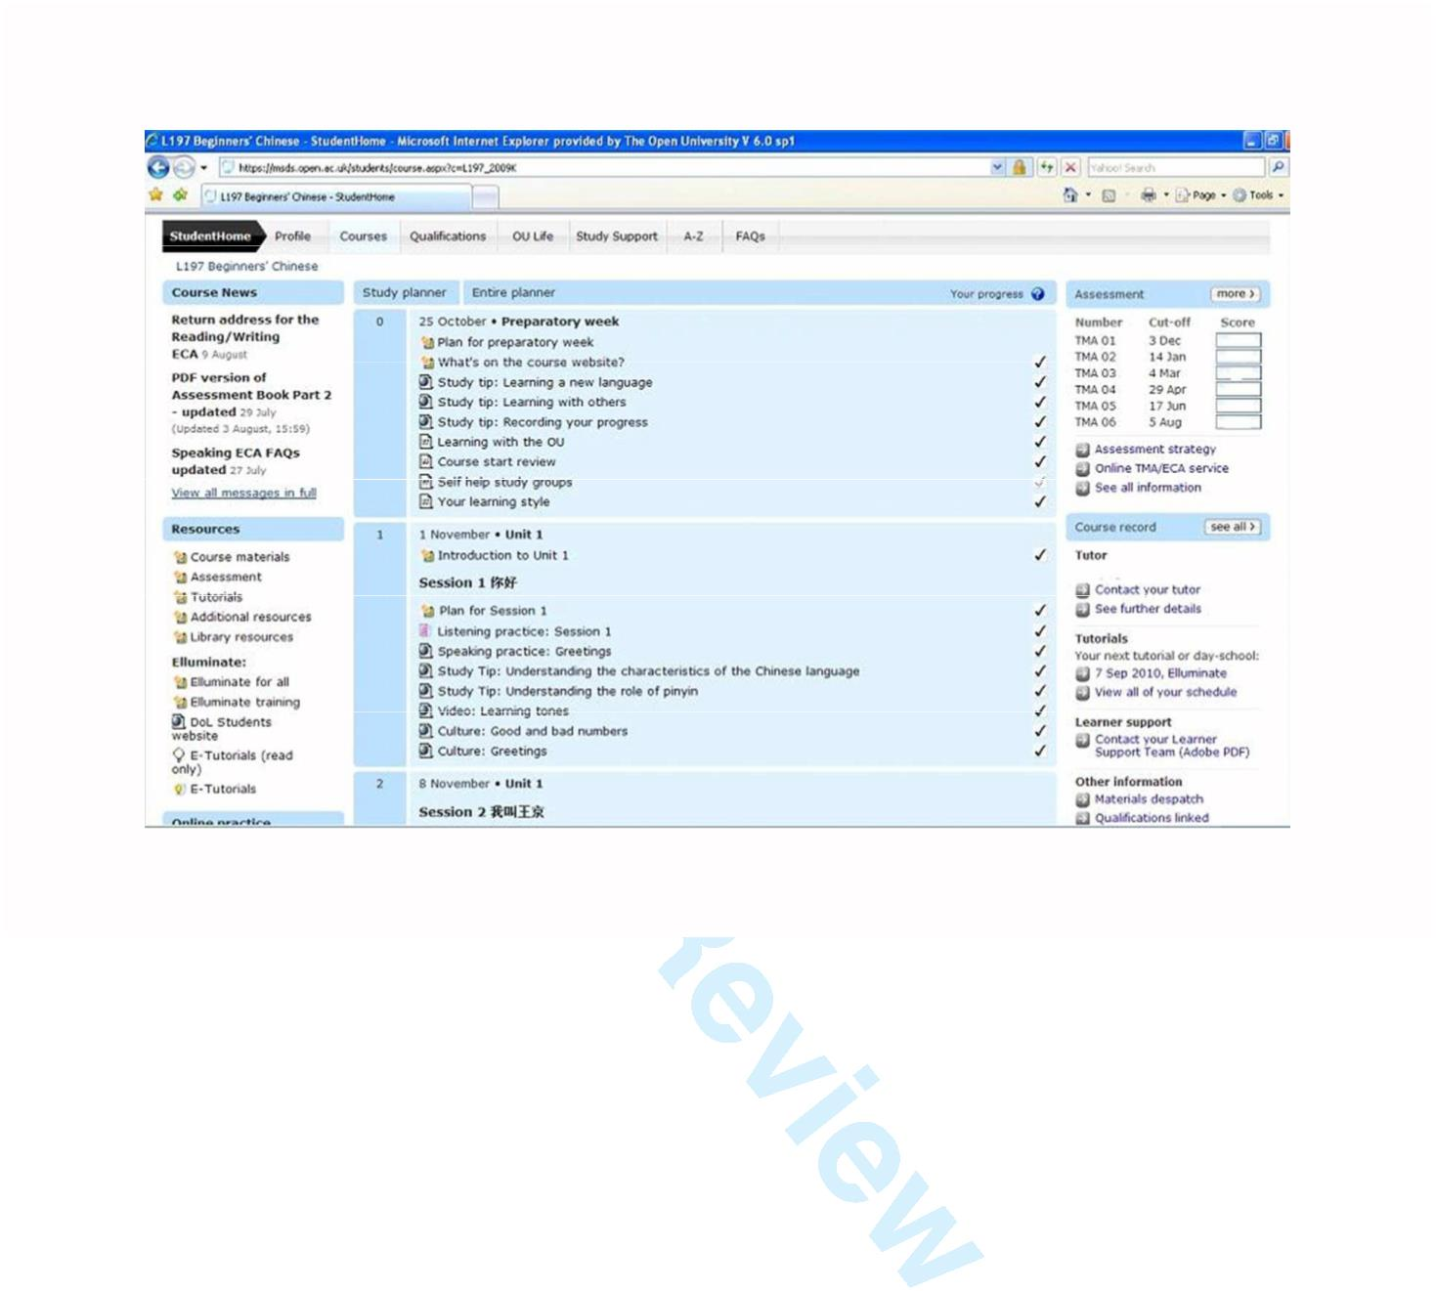

Page 23 of 33
Computer Assisted Language Learning
1
2
3
4
5
6
7
8
9
10
11
12
13
14
15
16
17
18
19
20
21
22
23
24
25
26
27
28
29
30
31
32
33
34
35
36
37
38
39
40
41
42
43
44
45
46
47
48
49
50
51
52
53
54
55
56
57
58
59
60
Figure 1: an extract from the course website of OU’s Beginners’ Chinese (at first weeks of the course).
218x133mm (96 x 96 DPI)
URL: http://mc.manuscriptcentral.com/ncal

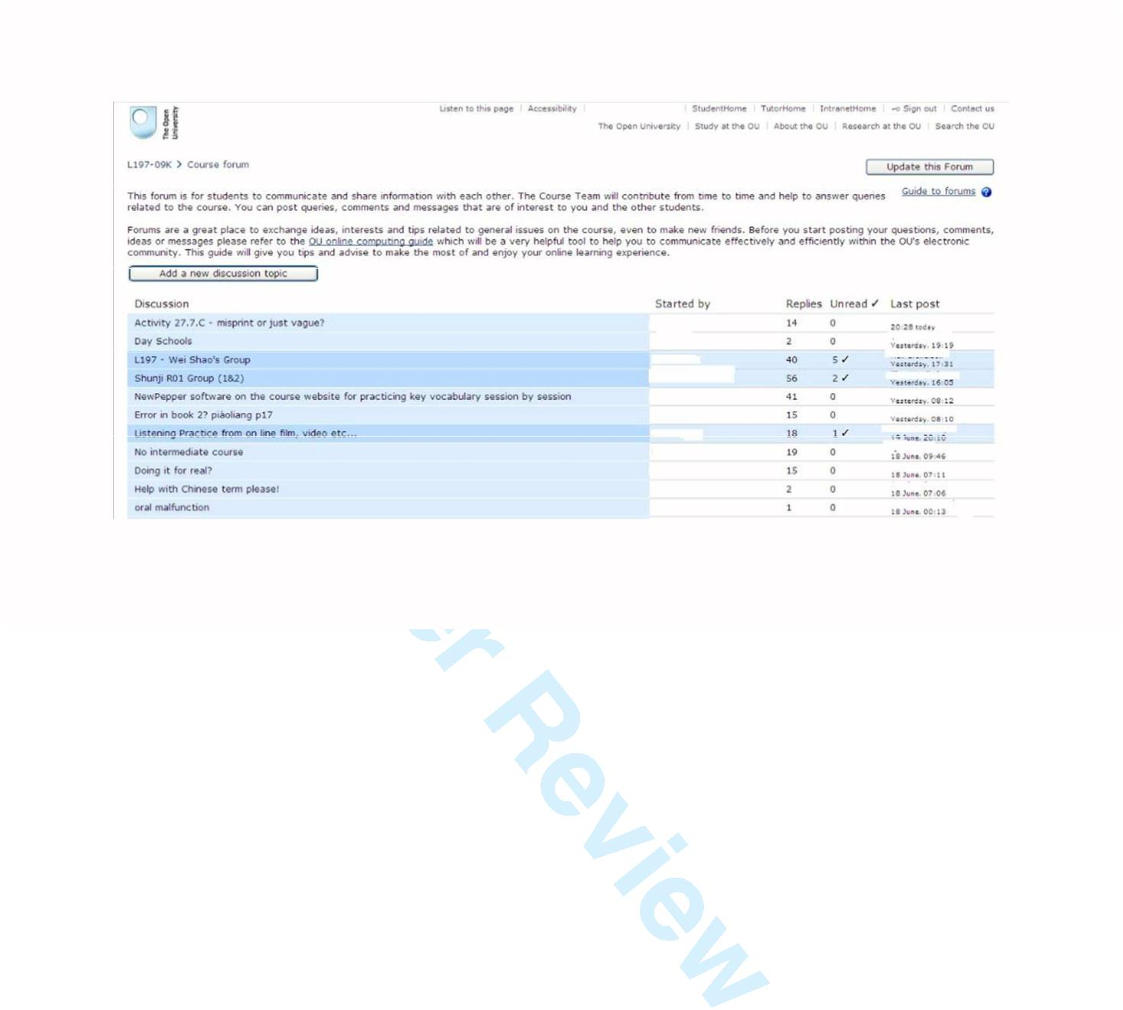
Computer Assisted Language Learning
Page 24 of 33
1
2
3
4
5
6
7
8
9
10
11
12
13
14
15
16
17
18
19
20
21
22
23
24
25
26
27
28
29
30
31
32
33
34
35
36
37
38
39
40
41
42
43
44
45
46
47
48
49
50
51
52
53
54
55
56
57
58
59
60
Figure 2: Front page of the Course forum showing a list of discussion topics. The names under ‘Started by’
have been deleted.
260x121mm (96 x 96 DPI)
URL: http://mc.manuscriptcentral.com/ncal

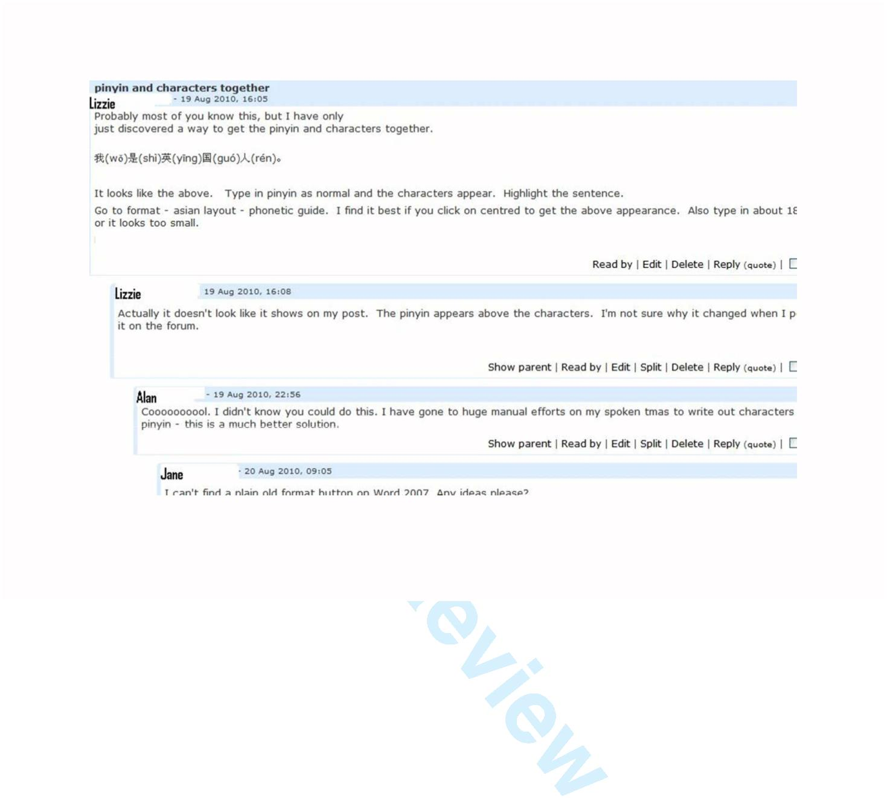
Page 25 of 33
Computer Assisted Language Learning
1
2
3
4
5
6
7
8
9
10
11
12
13
14
15
16
17
18
19
20
21
22
23
24
25
26
27
28
29
30
31
32
33
34
35
36
37
38
39
40
41
42
43
44
45
46
47
48
49
50
51
52
53
54
55
56
57
58
59
60
Figure 3: An extract within a particular discussion topic. All the names given are pseudonyms.
239x140mm (96 x 96 DPI)
URL: http://mc.manuscriptcentral.com/ncal

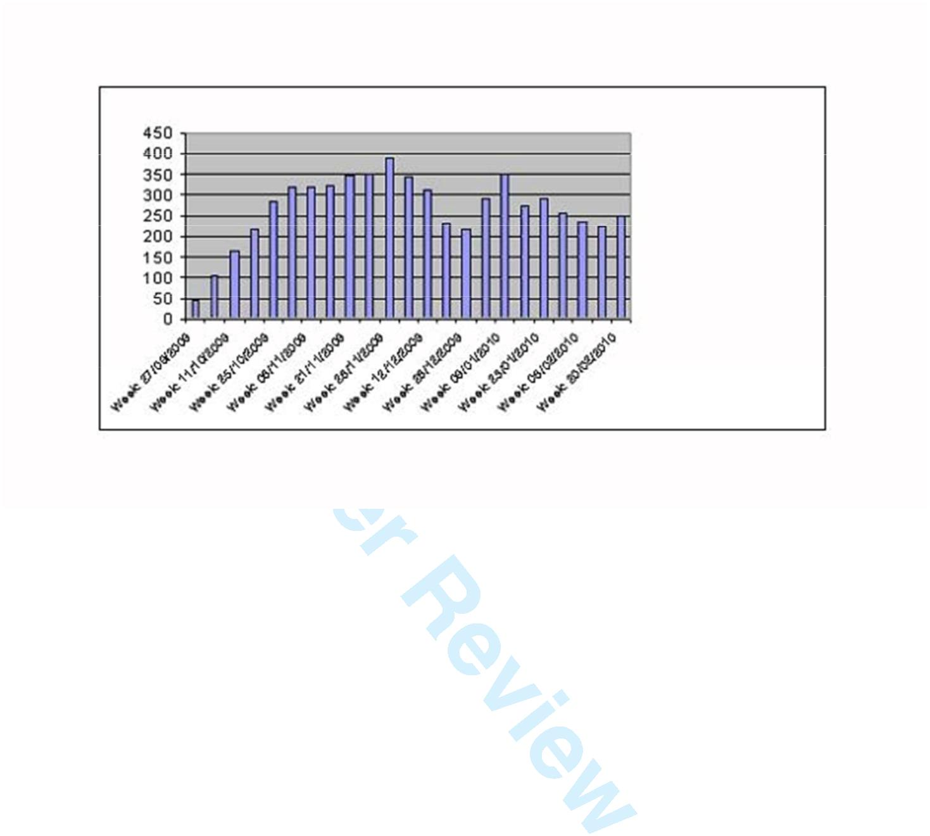
Computer Assisted Language Learning
Page 26 of 33
1
2
3
4
5
6
7
8
9
10
11
12
13
14
15
16
17
18
19
20
21
22
23
24
25
26
27
28
29
30
31
32
33
34
35
36
37
38
39
40
41
42
43
44
45
46
47
48
49
50
51
52
53
54
55
56
57
58
59
60
Figure 4: Weekly Course Forum Participation (unique user visits) between 27 Sept. 2009 – 20 Feb 2010.
130x63mm (96 x 96 DPI)
URL: http://mc.manuscriptcentral.com/ncal

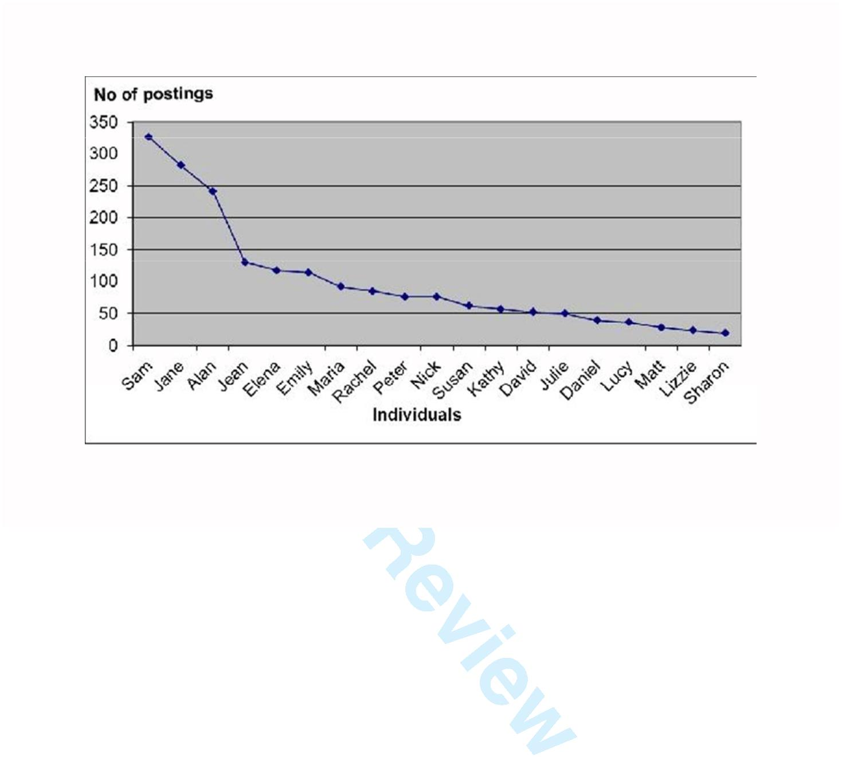
Page 27 of 33
Computer Assisted Language Learning
1
2
3
4
5
6
7
8
9
10
11
12
13
14
15
16
17
18
19
20
21
22
23
24
25
26
27
28
29
30
31
32
33
34
35
36
37
38
39
40
41
42
43
44
45
46
47
48
49
50
51
52
53
54
55
56
57
58
59
60
Figure 5: Number of messages posted by the top 20 contributors between October 2009 and September
2010.
161x89mm (96 x 96 DPI)
URL: http://mc.manuscriptcentral.com/ncal


Computer Assisted Language Learning
Page 28 of 33
Investigating online forums in distance Chinese language learning
1
2
3
4
5
6
<Table 1>
_____________________________________________________________________________
Gender
Male
Female
45%
55%
7
8
9
Age
under 25:
25 – 29:
30 – 39:
40 – 49:
50 – 59:
60 – 64:
over 65:
10%
10%
20%
19%
19%
11%
10%
10
11
12
13
14
15
16
17
18
19
20
21
22
23
24
25
26
27
28
29
30
31
32
33
34
35
36
37
38
39
40
41
42
43
44
45
46
47
48
49
50
51
52
53
54
55
56
57
58
59
60
Qualifications
No formal qualifications
Less Than 2 A-Levels
2+ A-Levels or Equivalent
HE Qualifications
Postgraduate Qualifications
Not Known
3%
12%
21%
37%
25%
2%
Ethnic origin
White
Asian
Black:
Mixed:
Other:
Not Known:
81%
7%
2%
2%
7%
6%
____________________________________________________________
Table 1: Beginners’ Chinese Students Profile. n= 467 (Source: Students Statistics Service, IET,
enrolment data 2009, The Open University, UK)
URL: http://mc.manuscriptcentral.com/ncal

Page 29 of 33
Computer Assisted Language Learning
Investigating online forums in distance Chinese language learning
1
2
3
4
5
6
7
8
<Table 2>
____________________________________________________________________________
Gender
male
female
Interviewees
7
8
9
10
11
12
13
14
15
16
17
18
19
20
21
22
23
24
25
26
27
28
29
30
31
32
33
34
35
36
37
38
39
40
41
42
43
44
45
46
47
48
49
50
51
52
53
54
55
56
57
58
59
60
Age
over 30 years-old
over 40 years-old
over 50 years-old
over 60 years-old
2
3
8
2
Frequency of usage
high users (i.e. 80+ postings on forum)
middle users (i.e. 20-79 postings)
low users (i.e. less than 20 postings)
non-posters (may not visit or only read
____________________________________________________________________________
Table 2: Gender, age and frequency of usage of the interviewees.
5
5
3
2
URL: http://mc.manuscriptcentral.com/ncal

Computer Assisted Language Learning
Page 30 of 33
Investigating online forums in distance Chinese language learning
1
2
3
4
5
<Table 3>
_____________________________________________________________________
6
7
What is the most important reason for you to study Chinese?
8
9
For pleasure and interest
As an intellectual challenge
To assist me in my present or future work
To be able to communicate with Chinese-speaking friends or family
To be able to communicate when visiting a Chinese-speaking country
As part of a wider programme (for instance, to obtain a degree)
25.4%
10
11
12
13
14
15
16
17
18
19
20
21
22
23
24
25
26
27
28
29
30
31
32
33
34
35
36
37
38
39
40
41
42
43
44
45
46
47
48
49
50
51
52
53
54
55
56
57
58
59
60
22.3%
18.1%
11.4%
9.3%
6.2%
__________________________________________________________
Table 3: Top six reasons for studying Chinese
URL: http://mc.manuscriptcentral.com/ncal

Page 31 of 33
Computer Assisted Language Learning
Investigating online forums in distance Chinese language learning
1
2
3
4
5
6
7
8
9
<Table 4>
________________________________________________________________
Less than 30 minutes
Between 30 - 45 minutes
Between 1 - 2 hours
Between 3 - 4 hours
More than 4 hours
43.8%
24.6%
20.8%
3.1%
10
11
12
13
14
15
16
17
18
19
20
21
22
23
24
25
26
27
28
29
30
31
32
33
34
35
36
37
38
39
40
41
42
43
44
45
46
47
48
49
50
51
52
53
54
55
56
57
58
59
60
3.1%
_____________________________________________________________________
Table 4: The length of time students spent visiting the Course forum per week. Source: Post-course
questionnaire.
URL: http://mc.manuscriptcentral.com/ncal

Computer Assisted Language Learning
Page 32 of 33
Investigating online forums in distance Chinese language learning
1
2
3
4
5
6
7
8
9
<Table 5>
______________________________________________________________________
November 2009
January 2010
Students
343
130
310
188
Visits
1118
298
3113
366
Students
332
117
225
144
Visits
771
486
2534
299
Assessment
Cafe forum
Course forum
Course
10
11
12
13
14
15
16
17
18
19
20
21
22
23
24
25
26
27
28
29
30
31
32
33
34
35
36
37
38
39
40
41
42
43
44
45
46
47
48
49
50
51
52
53
54
55
56
57
58
59
60
materials
Culture forum
151
447
102
______________________________________________________________________
316
Table 5: VLE statistics – comparing a selection of monthly activities on Beginners Chinese course website,
November 2009 and January 2010
URL: http://mc.manuscriptcentral.com/ncal

Page 33 of 33
Computer Assisted Language Learning
Investigating online forums in distance Chinese language learning
1
2
3
4
5
6
7
8
9
<Table 6>
________________________________________________________________________
Just to see what other students were saying and thinking about the course
When I wanted to find some good tips from my fellow students
When I had a query about a TMA or ECA
When I had a query about a language point in the course material
Other [supplied by students]
When I came across a computer related problem and needed to get support
When I felt I was behind and wanted to get some support
When I wanted to practice the language we had learnt
When I simply wanted to have a moan
51.4%
17.1%
9.9%
8.1%
6.3%
3.6%
2.7%
0.9%
0%
10
11
12
13
14
15
16
17
18
19
20
21
22
23
24
25
26
27
28
29
30
31
32
33
34
35
36
37
38
39
40
41
42
43
44
45
46
47
48
49
50
51
52
53
54
55
56
57
58
59
60
______________________________________________________________________________
Table 6: The most important reason for visiting the course forum n= 130
URL: http://mc.manuscriptcentral.com/ncal
View publication stats

